**DAILY ONLINE ACTIVITIES SUMMARY**

|  |  |  |  |  |  |  |  |  |
| --- | --- | --- | --- | --- | --- | --- | --- | --- |
| **Date:** | **10/06/2020** | | | | | **Name:** | **Anjali Manohar Prabhu** | |
| **Sem & Sec** | **4th Sem Section - ‘A’** | | | | | **USN:** | **4AL18CS007** | |
| **Online Test Summary** | | | | | | | | |
| **Subject** | | **OBJECT ORIENTED CONCEPT** | | | | | | |
| **Max. Marks** | | **30** | | **Score** | | | **18** | |
| **Certification Course Summary** | | | | | | | | |
| **Course** | **ARTIFICIAL INTELLIGENCE IN PYTHON** | | | | | | | |
| **Certificate Provider** | | | 1. **Great Learning Academy** | | **Duration** | | | **7hrs** |
| **Coding Challenges** | | | | | | | | |
| **Problem Statement:**   1. Write a C program to print the sum of boundary elements of a matrix | | | | | | | | |
| **Status: executed** | | | | | | | | |
| **Uploaded the report in Github** | | | | | **YES** | | | |
| **If yes Repository name** | | | | | [**https://github.com/vinisharen/lockdown-coding**](https://github.com/vinisharen/lockdown-coding) | | | |
| **Uploaded the report in slack** | | | | | **YES** | | | |

Online Test Details: OOC test was conducted online from the given timings, that is from 9:15 am to 9:45 am. It was 30 min time and there were 15 questions and each question had 2 marks. The marks that I scored was 18/30.

SNAPSHOT: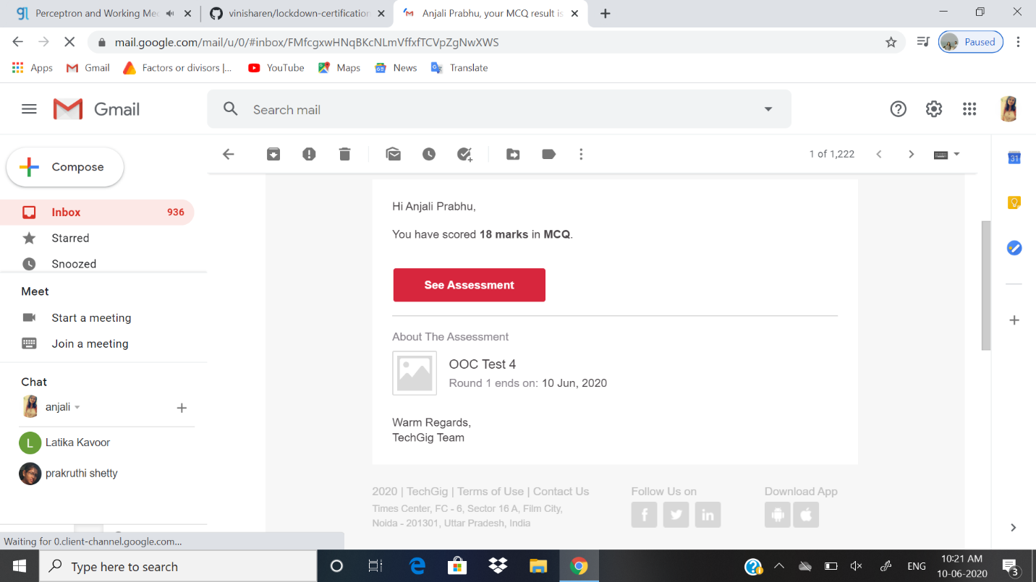

Certification Course Details: **Python** is commonly used in **artificial intelligence** projects and **machine learning** projects with the help of libraries like TensorFlow, Keras, Pytorch and Scikit-learn. As a scripting language with modular architecture, simple syntax and rich text processing tools, **Python** is often used for natural language processing.

**SNAPSHOT:**

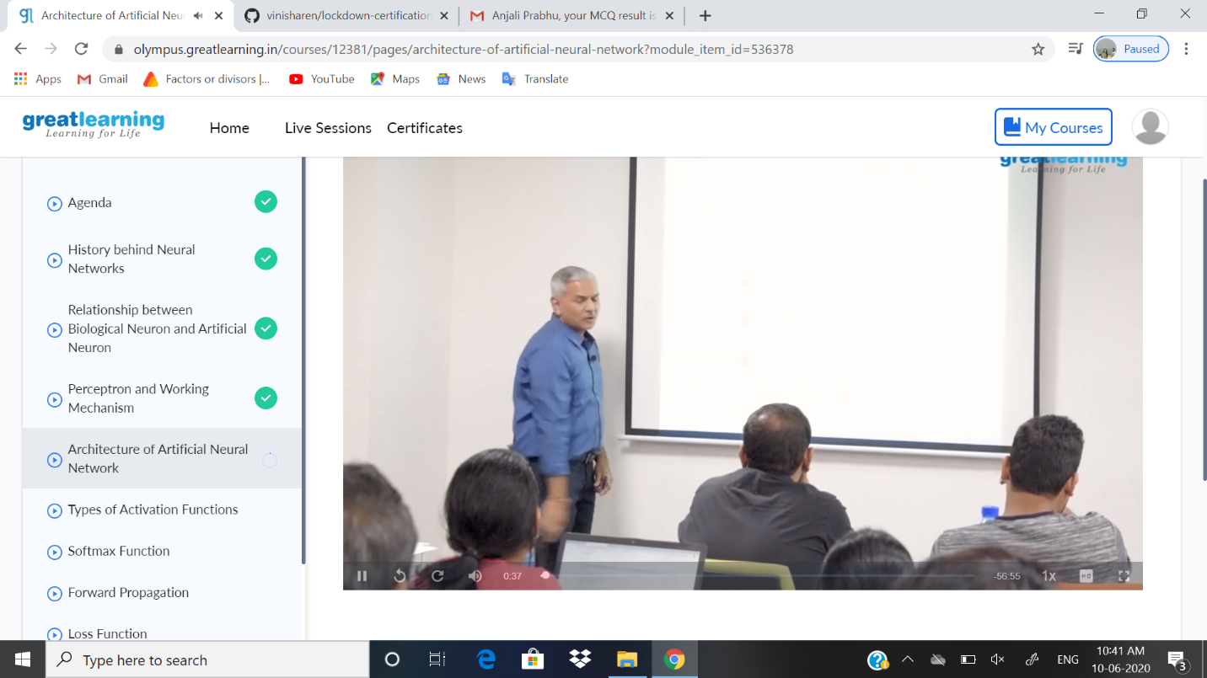

ONLINE CODING DETAILS:

1. PROBLEM 1:Write a C Program to print the sum of boundary elements of a matrix.

SNAPSHOT: 